**ACT/BAC1601; BAC1602; IBE1122: Fundamental of financial accounting**

Instructor: A. Issorasak Santivitoonvongs

อิศรศักดิ์ สันติวิฑูรวงศ์

**Tips in learning this course.**

* Pay attention especially for the first 3 chapters because it will create a strong basic knowledge for your best understanding.
* Practice the assignments.

We shall have two quizzes. 1st Quiz before midterm, and 2nd quiz before final. Dates will be informed later.

**MARKS ALLOCATION:**

* Quiz I and Quiz II (3% + 3%) 6%
* Attendance + Assignments 4%
* Mid-term exam 40%
* Final exam 50%

# TOTAL 100%

**What is Accounting?**

The definition of accounting given by AICPA (American Institute of Certified Public Accountant)

Accounting is the language of business. Accounting is also an information system because it contains Input, process and output.

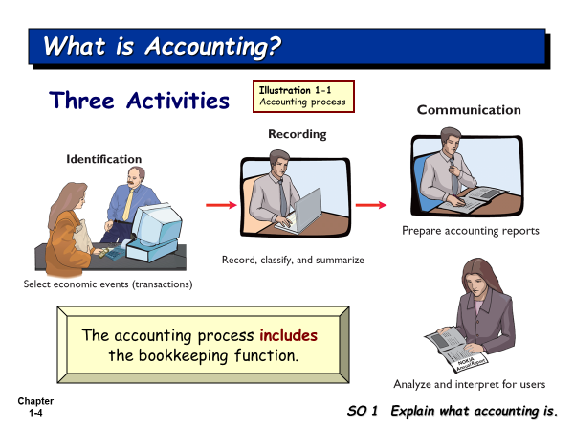

There are many events occurred every day. Some events are economic events, and other events are not. The accountant has to select the economic event for recording.

**What is the economic event (transaction)?**

It is the event which has impact on accounts in the **accounting equation**.

Identification is the most difficult activity. This activity is about how we can select the economic events from events. Then accountant will record the economic events in their books. Identification here is how to select and analyze the economic events.

The output of accounting is the **accounting reports** which will be submitted to the interested users of the accounting reports who want to use the accounting data.

**Accounting reports (Financial Statements) include**

1. Income Statement
2. Retained Earnings Statement
3. Statement of financial position
4. Cash Flow Statement
5. Note disclosure

**Who uses the accounting data?**

There are internal users and external users.

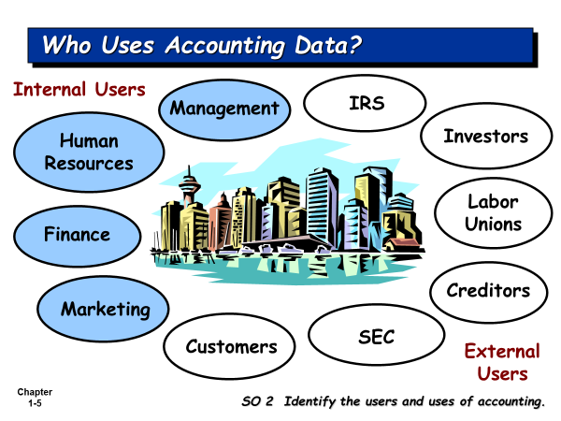

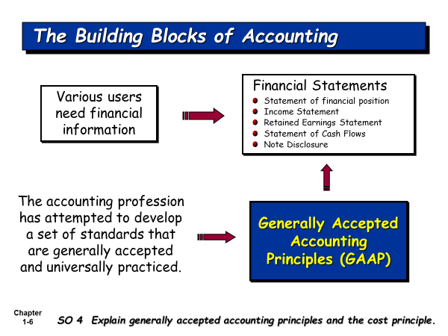

The financial statements must be prepared based on GAAP. Various users from various countries can read the reports and understand the same things from the reports. GAAP was developed by the accounting profession in order to get a set of standards which are generally accepted and universally practiced.

**What is GAAP?**

**Generally Accepted Accounting Principles (GAAP)** is the standard framework of guidelines for [financial accounting](http://en.wikipedia.org/wiki/Financial_accounting). It includes the standards, conventions, and rules that accountants follow in recording and summarizing transactions, and in the preparation of statements.

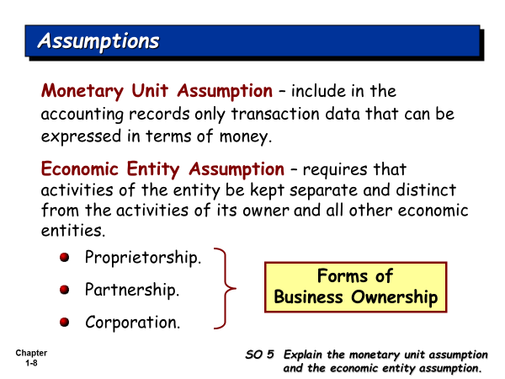

**Set up his company**

**Owner Organization (business firm)**

**Accountant** has to record the transactions for the business firm, not for the owner, because the accountant must hold the Economic Entity Assumption, that is, Owner and his business firm are the separate entity.

**Table 2.1 Some Accounting Concepts**

|  |  |
| --- | --- |
| **Basic Accounting Concepts** | **What It Means in Relationship to a Financial Statement** |
| **1. Separate Economic Entity Assumption** | Owner and his business firm are the separate entity. Shareholders are the separate entity from their company. |
| **2 Going Concern Assumption** | It is assumed that once the business firm is opened, the owner will run his business into the future quite long enough until he can meet his objectives. |
| **3. Monetary Unit Assumption** | An economic entity's accounting records include only quantifiable transactions. Accounting must be recorded using a stable currency e.g., the U.S. dollar, Thai Baht |
| **4. Time Period Assumption** | Most businesses exist for long periods of time (Going Concern Assumption). The accountant will artificially divide it into an equally time period, i.e., the company’s accounting period, which can be monthly, quarterly, and annually. We need to report the performance of our company under each accounting period. |
| **4. Historical Cost Principle** | **A**ssets are reported and presented at their original cost, e.g., our company bought equipment at 100,000 Baht, we record it at cost. |
| **5. Matching Principle (or Expense Recognition Principle)** | The matching principle requires that expenses incurred be matched with revenues generated from these expenses for an accounting period. |
| **6. Revenue Recognition Principle** | Revenue will be recognized (recorded) when our company’s service has been completed, or product has been delivered to customers, even money has not yet been collected. |
| **7. Full Disclosure Principle** | The full disclosure principle requires that financial statements include disclosure of information that is important to the users of the financial statements. It can be disclosed in the notes to the financial statement. |
| **9. Materiality** | Some expenses are very small, like taxi fare, stamps and so on, the accountant prefers to record them in one account, such as, Miscellaneous Expense. |
| **10. Conservatism Concept** | Under the uncertainty situation, the accountant will under-estimate the revenue and assets, and will over-estimate expenses and liabilities. |

1st act period (Jan 1- Dec 31)2nd act period (Jan 1, 2022 – Dec 31, 2022)

Jan 1, 2021 Dec 31,2021

I start my business on Jan 1, 2021. I want to run my business quite long enough until I can meet my objectives.

How can I measure the performance of my business firm? I want to know whether my business firm can make profit or not? We use the time period assumption in order to divide the life time of our business firm into an equal time period. We call it Accounting period. The companies in Thailand have accounting period of 1 year.

Net Income = Revenues – Expenses

How we recognize the revenue? We follow Revenue Recognition Principle.

How we recognize the expense? We follow Expense Recognition Principle (Matching).

**There are 3 forms of business ownership**

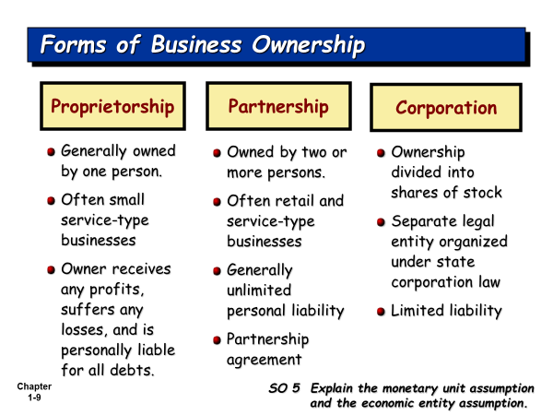

**Types of Business Operation**

1. **Service business**. The company sells the service (Complete/Provide/Rendered the service) to customers. Chapter 1 – 4 focuses recording business transactions for service business.
2. **Manufacturing business.** The company produces the products and sells the product to customers.
3. **Merchandising business**: The company buys the products, and then sells the product to customers. Chapter 5 focuses recording business transactions for merchandising business.

**Fields of Accounting**

1. **Financial Accounting:** The accounting reports will be presented to the internal and external users
2. **Managerial or Cost Accounting:** The managerial accounting reports will be used by the managers of all levels for their planning, directing, and controlling of their operations.
3. **Tax determination and planning**
4. **Public Accounting/ or independent audits**
5. **Data processing and information systems /or accounting information systems**
6. **National income accounting**

**Accounting Profession/or accounting career paths**

1. Accountants and accounting Manager in the private firms
2. Certified Public Accountant (External Auditor): Many accounting students wants to work with the BIG4 Companies. The Big4 Companies are the international audit firms, like, PricewaterhouseCoopers, Ernst & Young, Deloitte Touche Tohmatsu, and KPMG.
3. Cost accountant and Cost Account Manager
4. Internal Auditor
5. Tax Planning Officer/ Tax Planning Manager
6. Accounting System/Information System Designer
7. Government Accountant
8. Business Consultants

**Cash Basis Accounting** is the accounting method that revenues are recognized only when the company receives cash, and expenses are recognized only when the company pays cash.

**Accrual Basis Accounting is** the accounting method that recognizes revenue when they are earned even though cash has not yet been received; and recognizes expenses when they are incurred even cash has not yet been paid. Accrual basis accounting is considered to be the standard accounting practice for most business companies. GAAP recommends all business companies to use Accrual Basis of Accounting.

**Accounting Equation is the start of accounting recording.**

The accountant has to select the economic events from the events. The economic events will have impact on accounts in the accounting equation.

**Accounting Equation starts from**

**Assets = Equities**

*Resources of the firm = Sources of the firm’s resources*

**Assets = Equity of creditors (Liabilities) + Equity of owner**

*Resources of the firm Rights of creditors’ claims on the firm’s Rights of Owner’s claims resources on the firm’s resources*

How many forms of business ownership?

**Sole (Single) Proprietorship**

Assets = Liabilities + Owner’s Equity

**Partnership**

Assets = Liabilities + Owners’ Equity

**Corporation**

Assets = Liabilities + Stockholders’ Equity

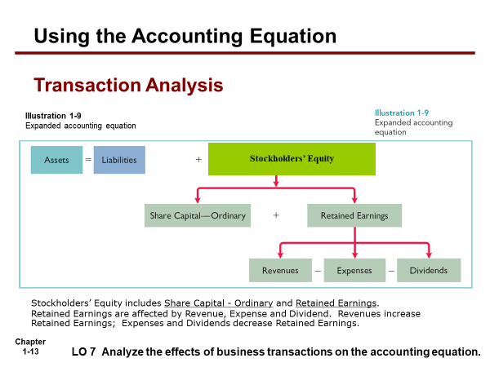

*Note: For intensive accounting, we focus on how to do the accounting record for single proprietorship; while the course Act1600 and Act 1601, we focus on how to do the accounting record for corporation.*

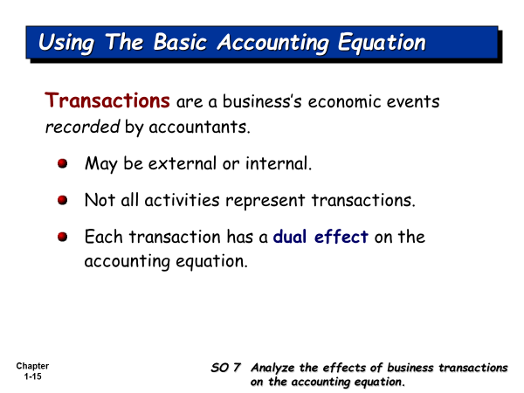

Do you know how to record life transactions for yourself?

You are the entity who is separated from your mother.

**Accounting equation for your personal life. Example here shows how to apply recording everyday life transactions.**

**Assets = Claims of creditors (Liability) + Parent’s Claim**

Cash + Book + Calculator = Supplier’s Claim + Friend’s Claim + Mother Capital

+1,000 = +1,000

- 800 + 800 .

**Bal. 200 + 800 = +1,000**

- 200 + 1,000 = + 800 .

**Bal -0- + 800 + 1,000 = + 800 +1,000**

+500 = +500 .

**Bal +500 + 800 + 1,000 = +800 +500 +1,000**

- 400 = - 400 (Ent exp)

-100 = - 100 (food exp)

**Bal -0- + 800 + 1,000 = +800 +500 +500**

+2,000 = +2,000

**Bal +2,000 + 800 + 1,000 = +800 +500 +2,500**

- 800 = - 800

- 500 = -500 .

**Bal +700 + 800 + 1,000 = -0- -0- +2,500**

Assets are the resources which you own.

Creditors’ claim and Parent’s claim are the sources of your resources.

**Class no. 2**

Accounting Equation for the company:

Assets = Liabilities + Stockholders’ Equity

Today we are going to practice doing problems in Chapter 1 and Chapter 2. We want to analyze the transactions based on accounting equation.

**Class no. 3**

Inform about the quiz 1 date is on Saturday, July 15, 2023, time 14.00 – 15.30. You can see your quiz room and seat on the board in front of SM 105, the Admins Office. Students, who passed Intensive Accounting about 1 year before, have their right not to take the quiz and get 3% full mark. Quiz 1 will cover Chapter 1 and 2, especially focus on Chapter 2.

We have learned how to analyze the transactions; now we are going to learn how the accountant records transactions in their books. Before we know it, we have to understand about debit and credit.

Debit is the left side; Credit is the right side.

Accounting Equation for the company.

Debit (Dr.) (Left) Credit (Cr.) (right)

Assets = Liabilities + Stockholders’ Equity

Notes:

1. Record Debit before credit in the General Journal
2. Record transactions in chronological order.
3. Record Debit amounts equal to Credit amounts. (Double Entry Accounting)
4. Double Entry Accounting has two types:

4.1) Simple Entry

4.2) Compound Entry

Normal balance of asset accounts is Debit

Normal balance of Liability accounts is Credit

Normal balance of Stockholders’ Equity accounts (Share Capital – Ordinary; Retained Earnings; Dividends)

Normal balance of revenue accounts is Credit

Normal balance of expense accounts is Debit

What is the Trial Balance?

It is the internal report of accountant to show the balances of accounts on the specified date of the report. It also checks whether the total debit amount equal to the total credit amount or not.

If you see the total debit amount equal to the total credit amount, Do you think that your work is totally correct?

**Accounting Cycle**

Transactions Journalize+Posting = Unadjusted TB + Adjusting Adjusted TB

Closing entry Post Closing TB

**Accounting reports**

**Summary of the Accounting Cycle (works of accountant in each accounting time period)**

1. Analyze transactions and business documents.

2. Journalize transactions.

3. Post journal entries to Ledger accounts.

4. Determine account balances and prepare a trial balance, then the accountant can get the Unadjusted Trial Balance.

5. Journalize and post adjusting entries to the ledger accounts, then the accountant can get Adjusted Trial Balance

6. Prepare financial statements (Accounting reports).

7. Journalize and post the closing entries, then the accountant can get the post-closing trial balance. The post-closing trial balance will contain the accounts and their balances which will be carried forward to the next accounting year period.

**Class No. 4**

Solution of Problem 2-4 and Problem 2-5. Show some mistakes in the students’ assignment.

Make sure that students know how to record transactions directly from the transactions by repeating problems in Chapter 2.

Show how to use T-accounts in replacement of ledger accounts. T-account is the simple form of account, and Ledger account is developed from T-account. Ledger accounts are mostly used by the accountants; while T-accounts are mostly used by students because it is easier to create them in the scratch paper.

**Quiz 1 date is on Saturday, July 15, 2023. Quiz time 14.00 – 15.30. Find your seat and room no. in front of Admins office, SM105.**

**Chapter 3: Adjusting entry**

**This chapter is the most difficult chapter. If you can pass it, other chapters would be easier. It requires your understanding until Chapter 2.**

**Why do we have to prepare adjusting entry?**

The accountant prepares adjusting entries at the end of accounting period in order to find the missing revenues and expenses in the period.



**Jan 1, 2022 Dec 31, 2022 Dec 31, 2023**

**Jan 1, 2023 Jan 1, 2024**

Assume I start my business on Jan 1, 2022. I have my intension to run my business until I am 100 years old which is very far from now. So, my company is running into the future time quite long enough until I can meet my objective.

I have a question that how can I measure my company’s performance? What should I know?

I want to know whether my company can make a profit or not? Where the profit comes from?

The profit comes from Revenue – Expenses

Do I have to wait until I am 100 years old when I stop my business, and after that you measure the company’s performance?

**I have to divide this time line into an equal time period (Time Period Assumption).** Then I can find the revenue for the period I want to measure, and the expenses for the same period.

**How can you recognize the revenue for the period?** We follow the Revenue Recognition Principle. How can you recognize the expense for the same period? We follow the matching principle.

**Why do we need to prepare adjusting entries at the end of the accounting period?**

Because some revenues and some expenses were missed. That’s why we prepare adjusting entries in order to recognize the missing revenues and expenses in the same period.

**There are 4 types of adjustment**: Prepaid expense type, unearned revenue type, Accrued Revenue type, and Accrued Expense type.

**Prepaid expense type of adjustment**: The prepaid expense has first been recorded in the asset account, and then will be adjusted for the asset used (or consumed), which becomes the expenses for the period.

Exercise 7 (1); Exercise 7 (4); Problem 3-2; Problem 3-5 (3); Problem 3-5 (4)

**Unearned revenue type of adjustment**: Cash has been received in advance for the service which has not yet been provided in the period, and the accountant first recorded it in the liability account. At the end of the accounting period the accountant will adjust for the service which has been completed in the period.

**Exercise 1; Exercise 7 (2); Problem 3-2 (2)**

**Accrued Revenue type of adjustment:** Revenue has been earned in the period, but has not yet been recognized. This event occurs at the end of accounting period.

**Exercise 7 (3); Exercise 7 (5); Problem 3-5 (5)**

**Accrued Expense type of adjustment:** Expense has been incurred in the period, but has not yet been recognized. This event occurs at the end of accounting period.

**Exercise 7 (6); Problem 3-2 (3); Problem 3-5 (1)**